**CONSIS INTERNATIONAL**

**Insurance Software & Business Solutions**

**Guía de configuración**

**de Bibliotecas compartidas en EAR**

**para *WebSphere 8***

OBJETIVO

El Objetivo de este documento se basa en presentar el procedimiento para la configuración de bibliotecas compartidas para distintas instalaciones (EARs) de Acsel-E en WAS 8.

## ***PROCEDIMIENTO PARA LA GENERACION DEL EAR MODO BIBLIOTECAS COMPARTIDAS***

1. En el archivo build.properties modificar la variable “acsele.share.lib” con el directorio donde desea que estén las librerías compartidas. Todos los directorios deben existir.
2. En el mismo archivo build.properties modificar la variable “acsele.share.lib.opt=true” para activar el modo de librerías compartidas.

Para efectos de este manual estas variables quedaran de la siguiente manera:

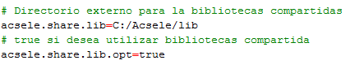

## ***PROCEDIMIENTO PARA LA CONFIGURACIÓN DE BIBLIOTECAS COMPARTIDAS DE ACSEL-E EN WAS 8.***

1. Verificar que los archivos fueron copiados a la ruta elegida (“C:/Acsele/lib”):

activation.jar

ant-1.6.5.jar

ant-launcher-1.6.5.jar

antlr-2.7.5.jar

antlr-2.7.7.jar

antlr-runtime-3.3.jar

aopalliance.jar

apache-mime4j-0.6.jar

appengine-api-1.0-sdk-1.2.1.jar

args4j-2.0.16.jar

atmosphere-compat-jbossweb-1.0.18.vaadin1.jar

atmosphere-compat-tomcat-1.0.18.vaadin1.jar

atmosphere-compat-tomcat7-1.0.18.vaadin1.jar

atmosphere-runtime-1.0.18.vaadin1.jar

avalon-framework-api-4.3.1.jar

avalon-framework-cvs-20020806.jar

avalon-framework-impl-4.3.1.jar

backport-util-concurrent-3.0.jar

barbecue-1.5-beta1.jar

batik-all-1.7.jar

batik.jar

billetConsis.jar

c3p0-0.9.1.2.jar

cglib-2.0-rc2.jar

commons-beanutils-1.7.0.jar

commons-beanutils.jar

commons-cli-1.2.jar

commons-codec-1.3.jar

commons-codec-1.8.jar

commons-collections-3.1.jar

commons-configuration-1.6.jar

commons-dbcp.jar

commons-digester-1.7.jar

commons-digester.jar

commons-fileupload.jar

commons-httpclient-3.1.jar

commons-io-1.3.1.jar

commons-io-1.4.jar

commons-io-2.2.jar

commons-jexl-2.1.1.jar

commons-lang-2.1.jar

commons-lang-2.4.jar

commons-lang-2.6.jar

commons-lang3-3.1.jar

commons-logging-1.0.4.jar

commons-logging-1.1.1.jar

commons-math-1.0.jar

commons-math3-3.0.jar

commons-net-1.4.1.jar

commons-pool.jar

commons-services.jar

commons-validator.jar

commons-vfs.jar

core-2.0.jar

cos.jar

cssparser-0.9.5.jar

db2jcc.jar

db2jcc4.jar

db2jcc_license_cu.jar

dbunit-2.4.5.jar

displaytag-1.1.jar

docx4j-3.2.1.jar

dom4j.jar

dwr-v2.jar

ecs-1.4.2.jar

ehcache-1.5.0.jar

eigenbase-properties.jar

eigenbase-resgen.jar

eigenbase-xom.jar

ESAPI-2.0-rc4.jar

FCKeditor-2.3.jar

filteringtable-0.9.8.v7.jar

fop-1.0.jar

GroboTestingJUnit-1.2.1-core.jar

groovy-all-2.1.9.jar

guava-14.0.1.jar

gwt-diagrams-0.2-RC00.jar

gwt-log-3.0.2.jar

gwt-servlet.jar

gwtext.jar

gwtextux.jar

hamcrest-core-1.3.jar

hibernate-tools.jar

hibernate2.jar

imap.jar

iReport.jar

iText-2.1.7.jar

itext-xtra-5.2.0.jar

itextpdf-5.2.0.jar

jai_codec.jar

jai_core.jar

jakarta-oro-2.0.8.jar

jakarta-regexp-1.2.jar

jasperreports-5.5.1.jar

javacup.jar

javase-2.0.jar

jaws.jar

jaxb-api-2.0.jar

jaxb-svg11-1.0.2.jar

jaxb-xmldsig-core-1.0.0.jar

jaxb-xslfo-1.0.1.jar

jaxen-1.1.3.jar

jcommon-1.0.0.jar

Jdom-fe.jar

Jdom.jar

jdt-compiler.jar

jep-2.3.0.jar

jetty-6.1.11.jar

jetty-util-6.1.11.jar

jfreechart-1.0.0.jar

jldap-4.3.jar

joda-time-1.6.jar

jodconverter-core-3.0-beta-4.jar

jpdf.jar

jpivot.jar

jrimum-bopepo-0.2.3-dep.jar

jrimum-bopepo.jar

jrimum-domkee-0.2.3-20111124.014941-2.jar

jrimum-utilix-0.2.3-20111124.014738-2.jar

jrimum-vallia-0.2.3-20111124.014850-2.jar

jsf-api.jar

jsoup-1.6.3.jar

jsr107cache-1.0.jar

jstl.jar

juh-3.2.1.jar

junit-4.11.jar

junit.jar

jurt-3.2.1.jar

jxl.jar

log4j-1.2.15.jar

log4j-1.2.jar

lwp.jar

mail.jar

mailapi.jar

mailer.jar

mondrian.dtd

mondrian.jar

odmg-3.0.jar

ojdbc6.jar

opttags.jar

OroMatcher.jar

p6spy.jar

PagedTable-0.6.5.jar

pager-taglib.jar

poi-3.10-FINAL-20140208.jar

poi-ooxml-3.10-FINAL-20140208.jar

poi-ooxml-schemas-3.10-FINAL-20140208.jar

poi-scratchpad-3.8.jar

pop3.jar

popupbutton-jar-2.2.1.jar

qrgen-1.3.jar

resolver.jar

ridl-3.2.1.jar

rptclient.jar

runtime.jar

saaj-api.jar

saaj-ri.jar

sac-1.3.jar

serializer-2.7.1.jar

serializer.jar

sigar.jar

slf4j-api-1.5.10.jar

slf4j-log4j12-1.5.10.jar

smartgwt-skins.jar

smartgwt.jar

smartjcommon_1.7.1.jar

smartjpdf_1.0.4.jar

smartsprites-0.2.10.jar

smtp.jar

spring.jar

standard.jar

stringtemplate-3.2.1.jar

struts-el.jar

struts-legacy.jar

struts.jar

swing-worker-1.1.jar

taglib-log.jar

taglibs-i18n.jar

tbutils-wcf.jar

unoil-3.2.1.jar

vaadin-client-7.1.11.jar

vaadin-client-compiled-7.1.11.jar

vaadin-client-compiler-7.1.11.jar

vaadin-client-compiler-deps-1.0.2.jar

vaadin-push-7.1.11.jar

vaadin-server-7.1.11.jar

vaadin-shared-7.1.11.jar

vaadin-shared-deps-1.0.2.jar

vaadin-slf4j-jdk14-1.6.1.jar

vaadin-theme-compiler-7.1.11.jar

vaadin-themes-7.1.11.jar

validation-api-1.0.0.GA-sources.jar

validation-api-1.0.0.GA.jar

wcf.jar

wmf2svg-0.9.0.jar

xalan-2.7.1.jar

xbean.jar

xercesImpl.jar

xhtmlrenderer-1.0.0.jar

xml-apis-1.3.04.jar

xml-apis.jar

xmlbeans-2.6.0.jar

xmlbeans-qname.jar

xmlgraphics-commons-1.4.jar

xmlpull-1.1.3.1.jar

xpp3-1.1.3.4d_b4_min.jar

xstream-1.4.3.jar

1. Con el explorador de su preferencia acceder a la consola de administración del servidor de aplicaciones WebSphere, por ejemplo: <https://localhost:9060/admin>.

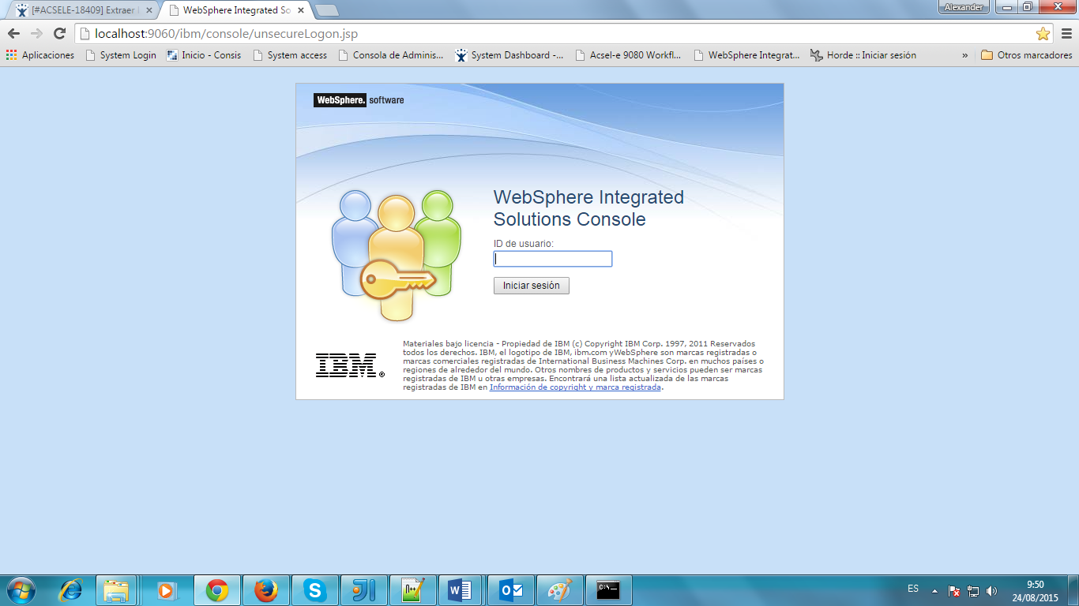

1. Seleccionar las opciones Entorno->Variables de WebSphere:

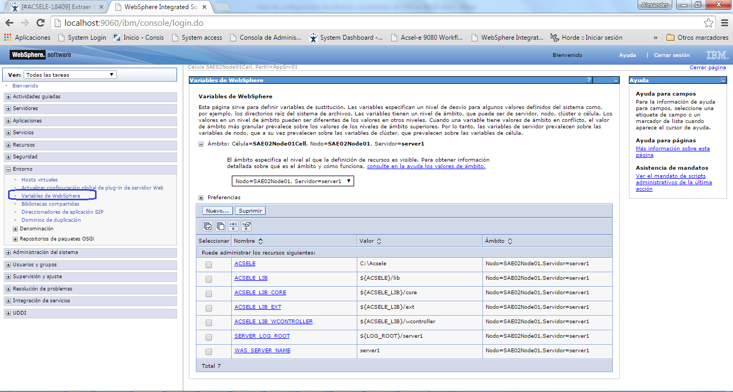

1. Se mostrará una pantalla conteniendo una tabla con las variables de WebSphere. Lo que sigue es seleccionar el servidor ó cluster donde se creará la nueva variable de WebSphere y para continuar se tiene que dar clic en el botón [Nuevo…].

Crear las variables, para efecto de este ejemplo.

ACSELE=C:\Acsele

ACSELE_LIB= ${ACSELE}/lib

ACSELE_LIB_WCONTROLLER= ${ACSELE_LIB}/wcontroller

**Nota:** Cuando se creen cada una de las variables, se mostrará en la parte superior un mensaje como el siguiente a los cuales se deberá pulsar la opción Guardar

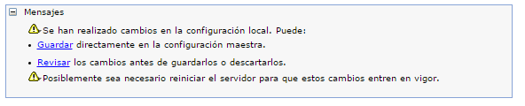

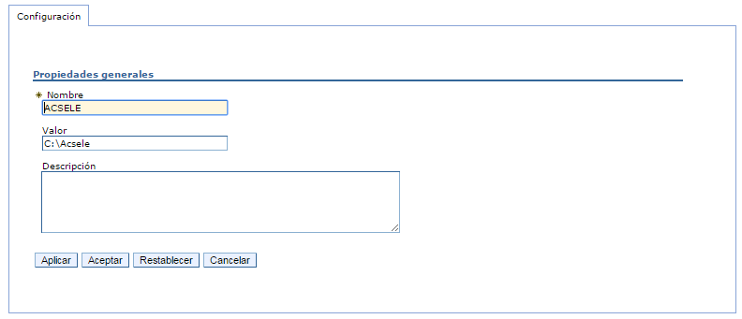

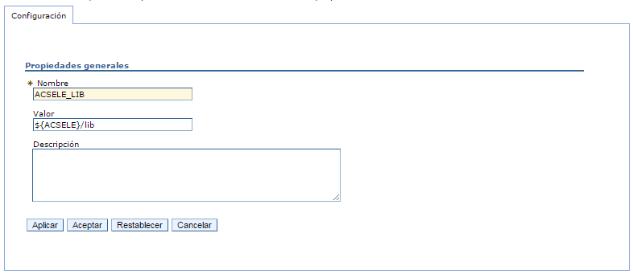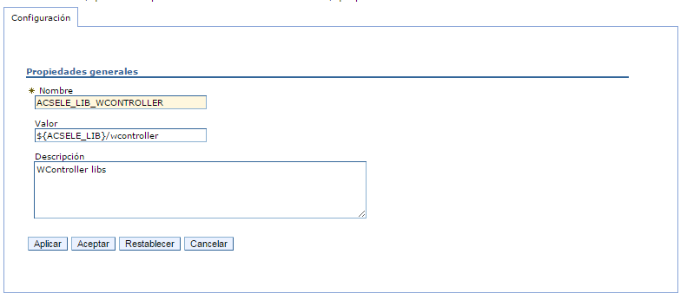

1. Seleccionar el apartado "Entorno" > "Biblioteca compartida".

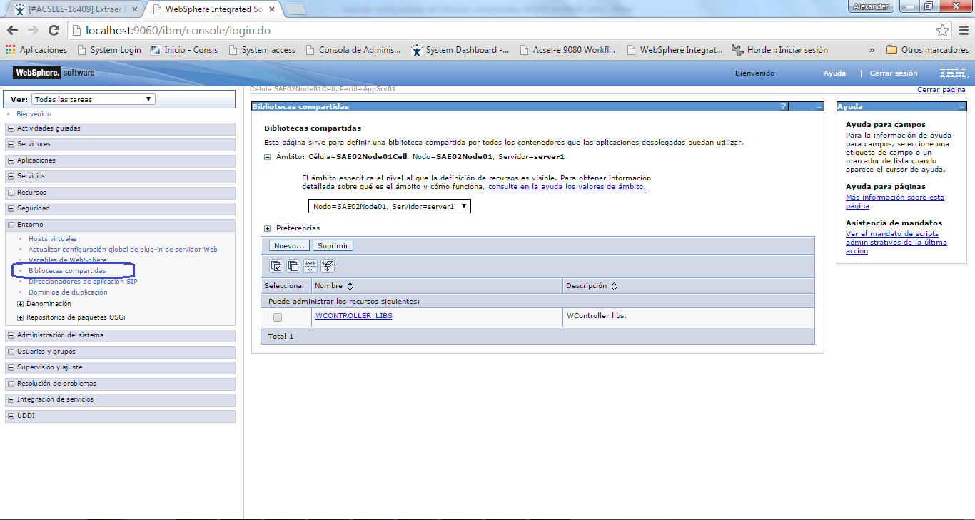

Se mostrará una pantalla conteniendo una tabla con las bibliotecas compartidas de WebSphere. Lo que sigue es seleccionar el servidor ó cluster donde se creará la nueva biblioteca compartida de WebSphere y para continuar se tiene que dar clic en el botón [Nuevo…].

1. Se muestra una pantalla donde se pide definir los siguientes parámetros. El primer parámetro corresponde al "Nombre" de la biblioteca compartida, donde se deberá colocar un identificador para la biblioteca compartida, para efectos de este manual colocar " WCONTROLLER_LIBS". El segundo se trata de una descripción. El tercero parámetro corresponde a la descripción, corresponde a el "Via de acceso de clases" de la biblioteca compartida, el cual deberá contener los jar's que le corresponden y que fueron definidos al principio de este manual. El cuarto especifica una vía de acceso opcional de las bibliotecas nativas (archivos DLL o SO) necesaria para esta biblioteca compartida.(dejar en blanco). El quinto dejar deseleccionado. La configuración quedaría de la siguiente manera:

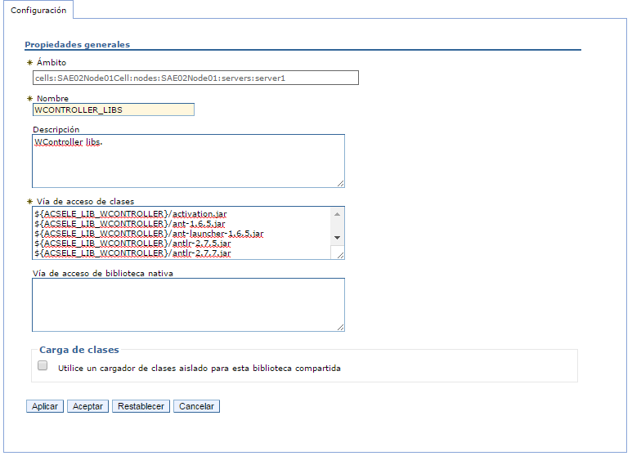

Para efectos de este manual:

${ACSELE_LIB_WCONTROLLER}/activation.jar

${ACSELE_LIB_WCONTROLLER}/ant-1.6.5.jar

${ACSELE_LIB_WCONTROLLER}/ant-launcher-1.6.5.jar

${ACSELE_LIB_WCONTROLLER}/antlr-2.7.5.jar

${ACSELE_LIB_WCONTROLLER}/antlr-2.7.7.jar

${ACSELE_LIB_WCONTROLLER}/antlr-runtime-3.3.jar

${ACSELE_LIB_WCONTROLLER}/aopalliance.jar

${ACSELE_LIB_WCONTROLLER}/apache-mime4j-0.6.jar

${ACSELE_LIB_WCONTROLLER}/appengine-api-1.0-sdk-1.2.1.jar

${ACSELE_LIB_WCONTROLLER}/args4j-2.0.16.jar

${ACSELE_LIB_WCONTROLLER}/atmosphere-compat-jbossweb-1.0.18.vaadin1.jar

${ACSELE_LIB_WCONTROLLER}/atmosphere-compat-tomcat-1.0.18.vaadin1.jar

${ACSELE_LIB_WCONTROLLER}/atmosphere-compat-tomcat7-1.0.18.vaadin1.jar

${ACSELE_LIB_WCONTROLLER}/atmosphere-runtime-1.0.18.vaadin1.jar

${ACSELE_LIB_WCONTROLLER}/avalon-framework-api-4.3.1.jar

${ACSELE_LIB_WCONTROLLER}/avalon-framework-cvs-20020806.jar

${ACSELE_LIB_WCONTROLLER}/avalon-framework-impl-4.3.1.jar

${ACSELE_LIB_WCONTROLLER}/backport-util-concurrent-3.0.jar

${ACSELE_LIB_WCONTROLLER}/barbecue-1.5-beta1.jar

${ACSELE_LIB_WCONTROLLER}/batik-all-1.7.jar

${ACSELE_LIB_WCONTROLLER}/batik.jar

${ACSELE_LIB_WCONTROLLER}/billetConsis.jar

${ACSELE_LIB_WCONTROLLER}/c3p0-0.9.1.2.jar

${ACSELE_LIB_WCONTROLLER}/cglib-2.0-rc2.jar

${ACSELE_LIB_WCONTROLLER}/commons-beanutils-1.7.0.jar

${ACSELE_LIB_WCONTROLLER}/commons-beanutils.jar

${ACSELE_LIB_WCONTROLLER}/commons-cli-1.2.jar

${ACSELE_LIB_WCONTROLLER}/commons-codec-1.3.jar

${ACSELE_LIB_WCONTROLLER}/commons-codec-1.8.jar

${ACSELE_LIB_WCONTROLLER}/commons-collections-3.1.jar

${ACSELE_LIB_WCONTROLLER}/commons-configuration-1.6.jar

${ACSELE_LIB_WCONTROLLER}/commons-dbcp.jar

${ACSELE_LIB_WCONTROLLER}/commons-digester-1.7.jar

${ACSELE_LIB_WCONTROLLER}/commons-digester.jar

${ACSELE_LIB_WCONTROLLER}/commons-fileupload.jar

${ACSELE_LIB_WCONTROLLER}/commons-httpclient-3.1.jar

${ACSELE_LIB_WCONTROLLER}/commons-io-1.3.1.jar

${ACSELE_LIB_WCONTROLLER}/commons-io-1.4.jar

${ACSELE_LIB_WCONTROLLER}/commons-io-2.2.jar

${ACSELE_LIB_WCONTROLLER}/commons-jexl-2.1.1.jar

${ACSELE_LIB_WCONTROLLER}/commons-lang-2.1.jar

${ACSELE_LIB_WCONTROLLER}/commons-lang-2.4.jar

${ACSELE_LIB_WCONTROLLER}/commons-lang-2.6.jar

${ACSELE_LIB_WCONTROLLER}/commons-lang3-3.1.jar

${ACSELE_LIB_WCONTROLLER}/commons-logging-1.0.4.jar

${ACSELE_LIB_WCONTROLLER}/commons-logging-1.1.1.jar

${ACSELE_LIB_WCONTROLLER}/commons-math-1.0.jar

${ACSELE_LIB_WCONTROLLER}/commons-math3-3.0.jar

${ACSELE_LIB_WCONTROLLER}/commons-net-1.4.1.jar

${ACSELE_LIB_WCONTROLLER}/commons-pool.jar

${ACSELE_LIB_WCONTROLLER}/commons-services.jar

${ACSELE_LIB_WCONTROLLER}/commons-validator.jar

${ACSELE_LIB_WCONTROLLER}/commons-vfs.jar

${ACSELE_LIB_WCONTROLLER}/core-2.0.jar

${ACSELE_LIB_WCONTROLLER}/cos.jar

${ACSELE_LIB_WCONTROLLER}/cssparser-0.9.5.jar

${ACSELE_LIB_WCONTROLLER}/db2jcc.jar

${ACSELE_LIB_WCONTROLLER}/db2jcc4.jar

${ACSELE_LIB_WCONTROLLER}/db2jcc_license_cu.jar

${ACSELE_LIB_WCONTROLLER}/dbunit-2.4.5.jar

${ACSELE_LIB_WCONTROLLER}/displaytag-1.1.jar

${ACSELE_LIB_WCONTROLLER}/docx4j-3.2.1.jar

${ACSELE_LIB_WCONTROLLER}/dom4j.jar

${ACSELE_LIB_WCONTROLLER}/dwr-v2.jar

${ACSELE_LIB_WCONTROLLER}/ecs-1.4.2.jar

${ACSELE_LIB_WCONTROLLER}/ehcache-1.5.0.jar

${ACSELE_LIB_WCONTROLLER}/eigenbase-properties.jar

${ACSELE_LIB_WCONTROLLER}/eigenbase-resgen.jar

${ACSELE_LIB_WCONTROLLER}/eigenbase-xom.jar

${ACSELE_LIB_WCONTROLLER}/ESAPI-2.0-rc4.jar

${ACSELE_LIB_WCONTROLLER}/FCKeditor-2.3.jar

${ACSELE_LIB_WCONTROLLER}/filteringtable-0.9.8.v7.jar

${ACSELE_LIB_WCONTROLLER}/fop-1.0.jar

${ACSELE_LIB_WCONTROLLER}/GroboTestingJUnit-1.2.1-core.jar

${ACSELE_LIB_WCONTROLLER}/groovy-all-2.1.9.jar

${ACSELE_LIB_WCONTROLLER}/guava-14.0.1.jar

${ACSELE_LIB_WCONTROLLER}/gwt-diagrams-0.2-RC00.jar

${ACSELE_LIB_WCONTROLLER}/gwt-log-3.0.2.jar

${ACSELE_LIB_WCONTROLLER}/gwt-servlet.jar

${ACSELE_LIB_WCONTROLLER}/gwtext.jar

${ACSELE_LIB_WCONTROLLER}/gwtextux.jar

${ACSELE_LIB_WCONTROLLER}/hamcrest-core-1.3.jar

${ACSELE_LIB_WCONTROLLER}/hibernate-tools.jar

${ACSELE_LIB_WCONTROLLER}/hibernate2.jar

${ACSELE_LIB_WCONTROLLER}/imap.jar

${ACSELE_LIB_WCONTROLLER}/iReport.jar

${ACSELE_LIB_WCONTROLLER}/iText-2.1.7.jar

${ACSELE_LIB_WCONTROLLER}/itext-xtra-5.2.0.jar

${ACSELE_LIB_WCONTROLLER}/itextpdf-5.2.0.jar

${ACSELE_LIB_WCONTROLLER}/jai_codec.jar

${ACSELE_LIB_WCONTROLLER}/jai_core.jar

${ACSELE_LIB_WCONTROLLER}/jakarta-oro-2.0.8.jar

${ACSELE_LIB_WCONTROLLER}/jakarta-regexp-1.2.jar

${ACSELE_LIB_WCONTROLLER}/jasperreports-5.5.1.jar

${ACSELE_LIB_WCONTROLLER}/javacup.jar

${ACSELE_LIB_WCONTROLLER}/javase-2.0.jar

${ACSELE_LIB_WCONTROLLER}/jaws.jar

${ACSELE_LIB_WCONTROLLER}/jaxb-api-2.0.jar

${ACSELE_LIB_WCONTROLLER}/jaxb-svg11-1.0.2.jar

${ACSELE_LIB_WCONTROLLER}/jaxb-xmldsig-core-1.0.0.jar

${ACSELE_LIB_WCONTROLLER}/jaxb-xslfo-1.0.1.jar

${ACSELE_LIB_WCONTROLLER}/jaxen-1.1.3.jar

${ACSELE_LIB_WCONTROLLER}/jcommon-1.0.0.jar

${ACSELE_LIB_WCONTROLLER}/Jdom-fe.jar

${ACSELE_LIB_WCONTROLLER}/Jdom.jar

${ACSELE_LIB_WCONTROLLER}/jdt-compiler.jar

${ACSELE_LIB_WCONTROLLER}/jep-2.3.0.jar

${ACSELE_LIB_WCONTROLLER}/jetty-6.1.11.jar

${ACSELE_LIB_WCONTROLLER}/jetty-util-6.1.11.jar

${ACSELE_LIB_WCONTROLLER}/jfreechart-1.0.0.jar

${ACSELE_LIB_WCONTROLLER}/jldap-4.3.jar

${ACSELE_LIB_WCONTROLLER}/joda-time-1.6.jar

${ACSELE_LIB_WCONTROLLER}/jodconverter-core-3.0-beta-4.jar

${ACSELE_LIB_WCONTROLLER}/jpdf.jar

${ACSELE_LIB_WCONTROLLER}/jpivot.jar

${ACSELE_LIB_WCONTROLLER}/jrimum-bopepo-0.2.3-dep.jar

${ACSELE_LIB_WCONTROLLER}/jrimum-bopepo.jar

${ACSELE_LIB_WCONTROLLER}/jrimum-domkee-0.2.3-20111124.014941-2.jar

${ACSELE_LIB_WCONTROLLER}/jrimum-utilix-0.2.3-20111124.014738-2.jar

${ACSELE_LIB_WCONTROLLER}/jrimum-vallia-0.2.3-20111124.014850-2.jar

${ACSELE_LIB_WCONTROLLER}/jsf-api.jar

${ACSELE_LIB_WCONTROLLER}/jsoup-1.6.3.jar

${ACSELE_LIB_WCONTROLLER}/jsr107cache-1.0.jar

${ACSELE_LIB_WCONTROLLER}/jstl.jar

${ACSELE_LIB_WCONTROLLER}/juh-3.2.1.jar

${ACSELE_LIB_WCONTROLLER}/junit-4.11.jar

${ACSELE_LIB_WCONTROLLER}/junit.jar

${ACSELE_LIB_WCONTROLLER}/jurt-3.2.1.jar

${ACSELE_LIB_WCONTROLLER}/jxl.jar

${ACSELE_LIB_WCONTROLLER}/log4j-1.2.15.jar

${ACSELE_LIB_WCONTROLLER}/log4j-1.2.jar

${ACSELE_LIB_WCONTROLLER}/lwp.jar

${ACSELE_LIB_WCONTROLLER}/mail.jar

${ACSELE_LIB_WCONTROLLER}/mailapi.jar

${ACSELE_LIB_WCONTROLLER}/mailer.jar

${ACSELE_LIB_WCONTROLLER}/mondrian.dtd

${ACSELE_LIB_WCONTROLLER}/mondrian.jar

${ACSELE_LIB_WCONTROLLER}/odmg-3.0.jar

${ACSELE_LIB_WCONTROLLER}/ojdbc6.jar

${ACSELE_LIB_WCONTROLLER}/opttags.jar

${ACSELE_LIB_WCONTROLLER}/OroMatcher.jar

${ACSELE_LIB_WCONTROLLER}/p6spy.jar

${ACSELE_LIB_WCONTROLLER}/PagedTable-0.6.5.jar

${ACSELE_LIB_WCONTROLLER}/pager-taglib.jar

${ACSELE_LIB_WCONTROLLER}/poi-3.10-FINAL-20140208.jar

${ACSELE_LIB_WCONTROLLER}/poi-ooxml-3.10-FINAL-20140208.jar

${ACSELE_LIB_WCONTROLLER}/poi-ooxml-schemas-3.10-FINAL-20140208.jar

${ACSELE_LIB_WCONTROLLER}/poi-scratchpad-3.8.jar

${ACSELE_LIB_WCONTROLLER}/pop3.jar

${ACSELE_LIB_WCONTROLLER}/popupbutton-jar-2.2.1.jar

${ACSELE_LIB_WCONTROLLER}/qrgen-1.3.jar

${ACSELE_LIB_WCONTROLLER}/resolver.jar

${ACSELE_LIB_WCONTROLLER}/ridl-3.2.1.jar

${ACSELE_LIB_WCONTROLLER}/rptclient.jar

${ACSELE_LIB_WCONTROLLER}/runtime.jar

${ACSELE_LIB_WCONTROLLER}/saaj-api.jar

${ACSELE_LIB_WCONTROLLER}/saaj-ri.jar

${ACSELE_LIB_WCONTROLLER}/sac-1.3.jar

${ACSELE_LIB_WCONTROLLER}/serializer-2.7.1.jar

${ACSELE_LIB_WCONTROLLER}/serializer.jar

${ACSELE_LIB_WCONTROLLER}/sigar.jar

${ACSELE_LIB_WCONTROLLER}/slf4j-api-1.5.10.jar

${ACSELE_LIB_WCONTROLLER}/slf4j-log4j12-1.5.10.jar

${ACSELE_LIB_WCONTROLLER}/smartgwt-skins.jar

${ACSELE_LIB_WCONTROLLER}/smartgwt.jar

${ACSELE_LIB_WCONTROLLER}/smartjcommon_1.7.1.jar

${ACSELE_LIB_WCONTROLLER}/smartjpdf_1.0.4.jar

${ACSELE_LIB_WCONTROLLER}/smartsprites-0.2.10.jar

${ACSELE_LIB_WCONTROLLER}/smtp.jar

${ACSELE_LIB_WCONTROLLER}/spring.jar

${ACSELE_LIB_WCONTROLLER}/standard.jar

${ACSELE_LIB_WCONTROLLER}/stringtemplate-3.2.1.jar

${ACSELE_LIB_WCONTROLLER}/struts-el.jar

${ACSELE_LIB_WCONTROLLER}/struts-legacy.jar

${ACSELE_LIB_WCONTROLLER}/struts.jar

${ACSELE_LIB_WCONTROLLER}/swing-worker-1.1.jar

${ACSELE_LIB_WCONTROLLER}/taglib-log.jar

${ACSELE_LIB_WCONTROLLER}/taglibs-i18n.jar

${ACSELE_LIB_WCONTROLLER}/tbutils-wcf.jar

${ACSELE_LIB_WCONTROLLER}/unoil-3.2.1.jar

${ACSELE_LIB_WCONTROLLER}/vaadin-client-7.1.11.jar

${ACSELE_LIB_WCONTROLLER}/vaadin-client-compiled-7.1.11.jar

${ACSELE_LIB_WCONTROLLER}/vaadin-client-compiler-7.1.11.jar

${ACSELE_LIB_WCONTROLLER}/vaadin-client-compiler-deps-1.0.2.jar

${ACSELE_LIB_WCONTROLLER}/vaadin-push-7.1.11.jar

${ACSELE_LIB_WCONTROLLER}/vaadin-server-7.1.11.jar

${ACSELE_LIB_WCONTROLLER}/vaadin-shared-7.1.11.jar

${ACSELE_LIB_WCONTROLLER}/vaadin-shared-deps-1.0.2.jar

${ACSELE_LIB_WCONTROLLER}/vaadin-slf4j-jdk14-1.6.1.jar

${ACSELE_LIB_WCONTROLLER}/vaadin-theme-compiler-7.1.11.jar

${ACSELE_LIB_WCONTROLLER}/vaadin-themes-7.1.11.jar

${ACSELE_LIB_WCONTROLLER}/validation-api-1.0.0.GA-sources.jar

${ACSELE_LIB_WCONTROLLER}/validation-api-1.0.0.GA.jar

${ACSELE_LIB_WCONTROLLER}/wcf.jar

${ACSELE_LIB_WCONTROLLER}/wmf2svg-0.9.0.jar

${ACSELE_LIB_WCONTROLLER}/xalan-2.7.1.jar

${ACSELE_LIB_WCONTROLLER}/xbean.jar

${ACSELE_LIB_WCONTROLLER}/xercesImpl.jar

${ACSELE_LIB_WCONTROLLER}/xhtmlrenderer-1.0.0.jar

${ACSELE_LIB_WCONTROLLER}/xml-apis-1.3.04.jar

${ACSELE_LIB_WCONTROLLER}/xml-apis.jar

${ACSELE_LIB_WCONTROLLER}/xmlbeans-2.6.0.jar

${ACSELE_LIB_WCONTROLLER}/xmlbeans-qname.jar

${ACSELE_LIB_WCONTROLLER}/xmlgraphics-commons-1.4.jar

${ACSELE_LIB_WCONTROLLER}/xmlpull-1.1.3.1.jar

${ACSELE_LIB_WCONTROLLER}/xpp3-1.1.3.4d_b4_min.jar

${ACSELE_LIB_WCONTROLLER}/xstream-1.4.3.jar

1. Por ultimo debe ingresar a la opción Aplicaciones-> Tipo de aplicaciones -> Aplicaciones de empresa de WebSphere:

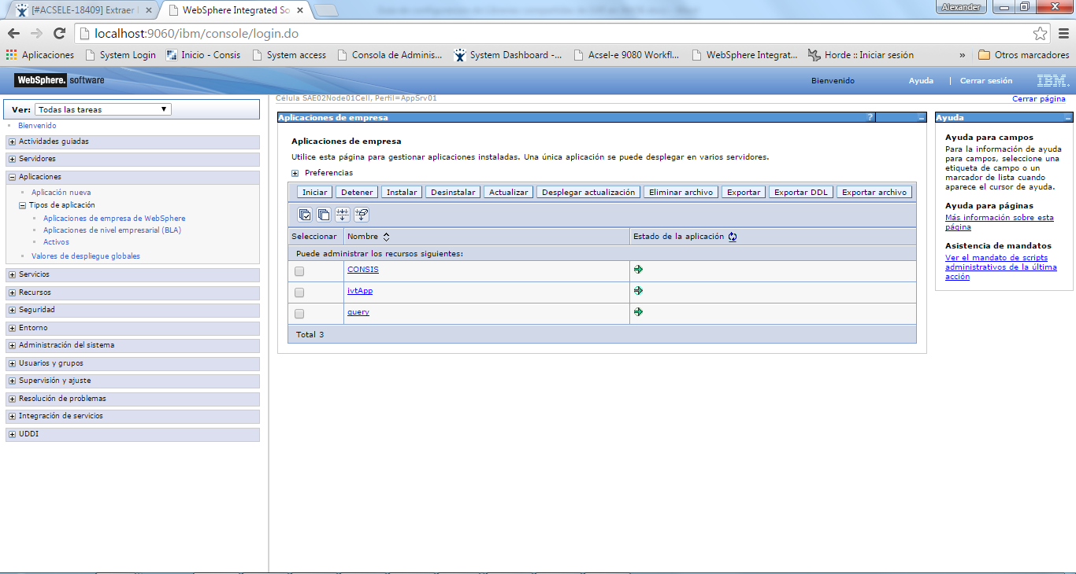

Seleccionar el EAR correspondiente.

1. Seleccionar la opción “Referencia de blibliotecas compartidas”:

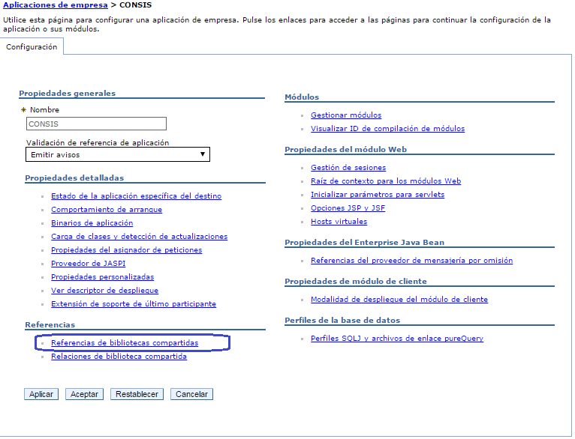

1. Seleccionar el WAR correspondiente y pulsar el botón “Bibliotecas compartidas de referencia”, para efectos de este ejemplo WCONTROLLER.war

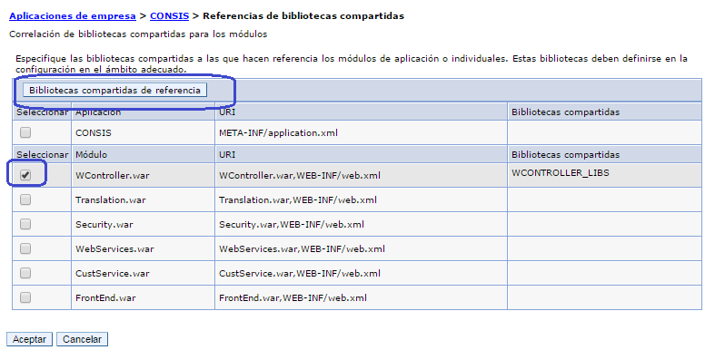

1. Seleccionar la biblioteca disponible, guardar los cambios y reiniciar el servidor de apliaciones WS8: 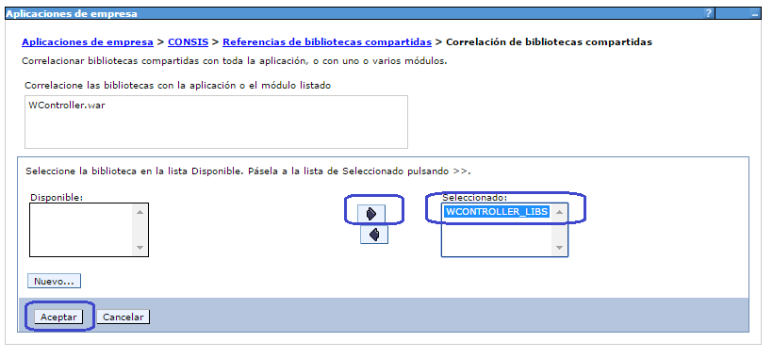

**Nota Final Importante:** Recordar que el cargador de clases deber ser único para la aplicación:

